The Fabulous Fifties
NEWSLETTER Special Edition

DICK GULDSTRAND
By Art Evans

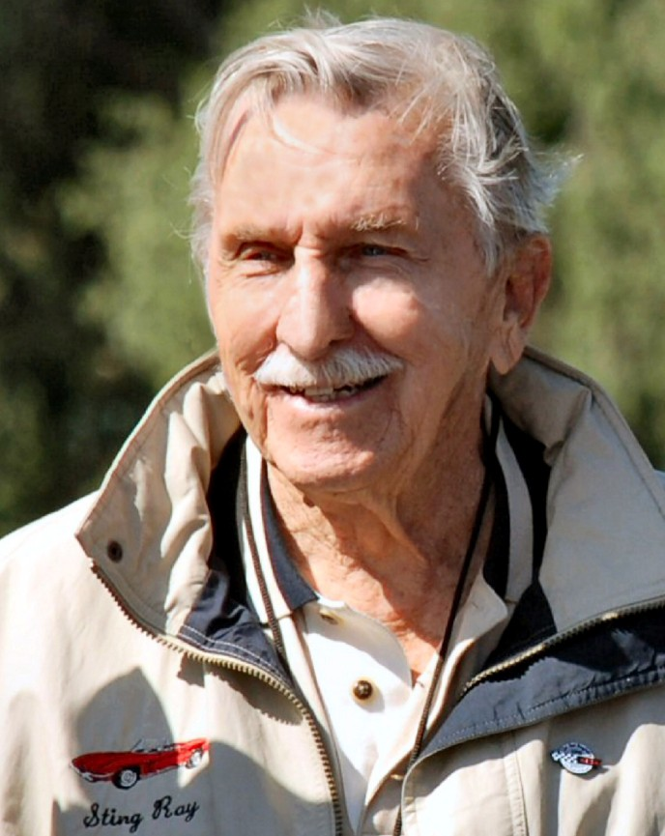
Photo by Steve Johnson

We lost another legend of the fabulous fifties when Dick Guldstrand died on Sep- tember 2 at age 87. My relationship with Dick was personal and goes way back. Dur- ing the late fifties, he raced his Corvette in Southern California in big-bore production events, as did I in my Jaguar. We met at one of those events and became fast friends.
In 1969, he opened a shop in Culver City where he specialized in Corvettes. At the time, I was a Culver City reserve police of- ficer so we often had lunch and hung out together. Some time ago, I acquired a 1976 Jaguar sedan whose looks and comfort I greatly admired. The engine, however, was not so great. After Dick prepared and in- stalled a Vette engine, it went like a rocket.
Over the years, “Uncle Richard,” as I sometimes called him (Although he was only seven years older than I.), remained close. He was a long-time active non-member and a recipient of our 2009 Lindley Bothwell Life- time Achievement Award. For the past two of our banquets, I reserved a seat for him at my table. Unfortunately, he was never well enough to attend.
Richard Herman Guldstrand was born on December 1, 1927 in Los Angeles. His father was an engineer and his mother performed in vaudeville. Dick attended Los Angeles High School where he lettered in track. Early on he was interested in hot rods.
While in high school, he installed a 1927 Ford Model T Roadster body on a 1932 frame. (below)

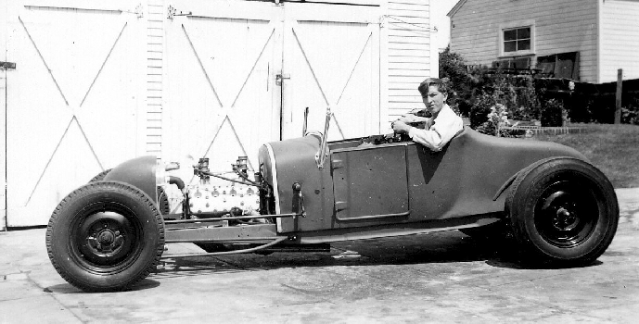

His early racing was in midgets and sprinters at Southern California circle tracks. He got his first job in 1947 at the Delta Elec- tric Company as an engineering aide, and, at the same time, attended Los Angeles City College.
In 1950, the Korean War started and Guldstrand joined the Army. He was sent to the Fort Bliss Missile Academy. Then he was assigned to work on radar systems, achieving the rank of technical sergeant. Discharged in 1952, he went to UCLA majoring in engi- neering. Afterwards he studied industrial electronics at Pasadena City College. Dick was an aerospace engineer, a profession at which he worked through 1962. He was in- volved in the design and development of a meteorological system for the Pacific Missile Range as well as other missile projects.
Dick Guldstrand and Corvettes have been closely associated for many years. While he has succeeded in other types of cars, his most important victories have come at the wheels of Corvettes. When Corvettes began to be successful at Southern California amateur road races, Guldstrand got interest- ed: “During the fifties, I had been racing sprinters, but I wanted to get into sports-car racing. I decided I wanted a Corvette. I found a beautiful little ’56 for sale so I bought it,” Dick wrote in my book, Racing Sports Cars. (enthusiastbooks.com, 800-289-3504)
General Motors honcho Ed Cole entered a Corvette team at Sebring in 1956 with John Fitch at the helm. Due to Fitch’s talents, the cars were transformed from boulevard cruis- ers into serious competitors in the production class. This involved various modifications that had to be offered by Chevrolet dealers if the cars were to be allowed in that class. This wasn’t widely known at the time, but Dick picked up on the fact and proceeded to trans- form his car. But unlike others who tried to “hot rod” Vettes, Guldstrand was a serious engineer.
For the next few years as Chevrolet came out with improved models and options, instead of buying later cars, he kept modify- ing his ’56 which he continued to race into the sixties. (below)

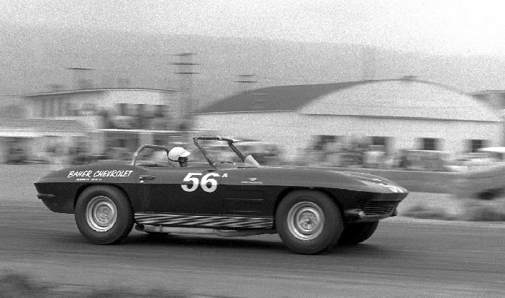
Dick in his 56 Corvette at Santa Barbara. Pho- to by Alan Kuhn

Guldstrand started racing his Corvette with the California Sports Car Club and the Sports Car Club of America in 1958. But pursuing a demanding aerospace career didn’t leave much time and energy for se- rious race driving. So in 1962, he shifted career gears and went to work for Baher Chevrolet as the Fleet Manager and ran the Baher Racing Team. Driving production Corvettes, Guldstrand won the Pacific Coast Championship in 1963, ‘64 and ’65 as well as the Southern Pacific B-Production Class Championship in 1964.

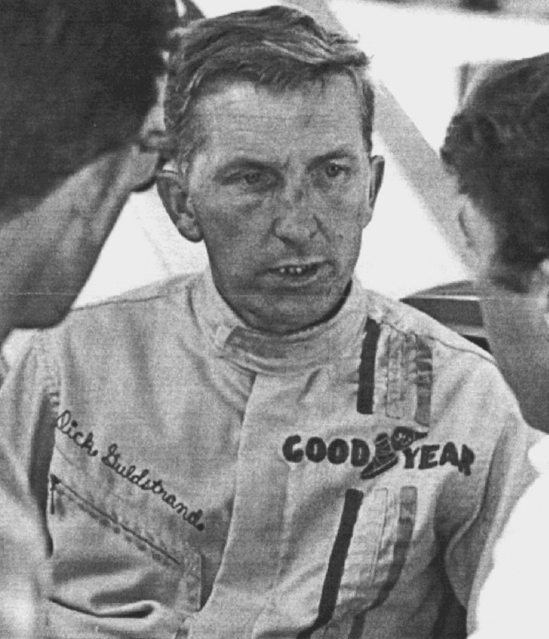
He was named the California Sports Car Club Region of the Sports Car Club of Amer- ica Driver of the Year in 1964. His success, however, was due not only to his driving, but also his engineering ability that resulted in superior handling.

Guldstrand’s amateur success came to the attention of Roger Penske for whom he drove as a professional for two years. 1966 was his best year. With co-drivers Ben Moore and George Wintersteen, he won first in the Grand Turismo class at Daytona. Then at Sebring, Guldstrand and Dick Thompson led the class for much of the race until sidelined by a shunt. Starting in 1967, Guldstrand drove a Camaro Z-28 for Dana Chevrolet in the Trans-Am Series, winning at St. Jovite, Riverside and Stardust in Las Vegas.
He and Bob Bondurant drove a Dana Corvette at Le Mans. They led their class for the first 13 hours until the engine failed. In the meantime, they set a new Grand Touris- mo lap record. Dick Guldstrand told William Edgar about how he and Bondurant took an Arkus-Duntov skunkworks L88 to Le Mans in 1967. Well, he flew the car to France-but the supposed GM help there didn't happen. "So Bobby and I drove the car from Orleans to Le Mans,and this thing wouldn't idle under 70 miles an hour-it was a huge 427 big block with side pipes and a 2.7 rear end. We were going through the countryside, smoke and flames following a hundred feet behind!" Foreign to French ears, the bellow of a migh- ty Chevy V8 thrilled villagers all along the way. Guldstrand hadn't run Le Mans before, so Bondurant did his best to teach him the 8- mile course in an Opel that was 100 miles an hour slower than what the L88 could do on the Mulsanne Straight. When Guldstrand drove the full Circuit de la Sarthe solo in their red-white-&-blue 427, maybe it's best told by him: "I'm going down the Mulsanne and here comes this wild-ass right-hand cor- ner that wasn't there the night before. So I'm hanging on for dear life and slid through this thing at 180, and I made it! But, when you get back in the pits you have what you call a 'Mulsanne Stain.”
Dick’s interest, however, developed into automotive design and fabrication in addition to racing. In 1969, he opened his own shop in Culver City, California. One of the first jobs the new organization received was to build Z/28 Camaros for the South American series. Dick himself ended up driving and won the South American Championship in 1969.
The next job was to build and develop Corvettes and Lola Can-Am cars for James Garner. He also managed the Garner team for two years. During the seventies, Guldstrand Engineering built some three-quarters of the Chevrolet-powered cars then racing on the West Coast. In 1973, Guldstrand-prepared cars won the A-Production, B-Production and A-Sedan SCCA National Championships.
By the eighties, Dick and Guldstrand Engineering had gained the confidence of Chevrolet factory folks as well as Zora-Arkus Duntov. In 1985, he developed the Corvette GS-80 model, which was Dick’s personal dream of a high-performance car. This was followed a decade later by the GS-90 based on the ZR-1. Fifty years after the introduction
of the Corvette, Guldstrand announced the 50th Anniversary Edition in 2003, offered by selected Chevrolet dealers. All three of these special edition Corvettes offered much supe- rior handling and performance while at the same time being suitable for casual touring.

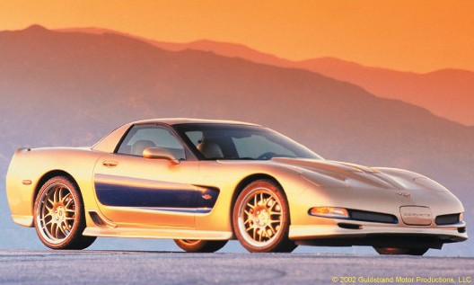

By then, he was known as “Mister Cor- vette,” Guldstrand Engineering not only pre- pared cars for racing but also serviced and modified customers’ street vehicles. In addi- tion, he marketed a wide variety of special parts and accessories.
Some years later, Dick moved his opera- tion from the original Culver City location to Burbank, near his home in North Hollywood. (I always wondered how Dick put up with the commute from the San Fernando Valley to Culver City! As L.A. traffic got more and more congested, I guess the drive finally got to him.)
During the ninties, we worked together on a spec-car project. The concept was to make an open-wheel car that would be inex- pensive as well as relatively easy for any mechanic to assemble. Dick’s design, except for a simple tube frame and fiberglass body, used only off-the-shelf components and cost less than $10,000. As it turned out, the angel for the project sold out and the cars were never made , but the sponsor paid Dick for his services (Not nearly enough, I thought.) The Guldstrand design was so ingenious that I think it would make the basis for a viable SCCA spec-car series even today.
Dick is survived by his second wife, Wil- ly, who he married in 1974, his brother Bob, and six grandchildren. He had two children, Gary and Gay with his first wife. In addition he had a stepchild, Victor. There is a possibil- ity that there will be a “Celebration of Life” at a future date. We’ll keep you posted.

GULDSTRAND LETTERS
I remember when Dick told me about racing that L-88 Corvette at LeMans. First of all he liked to tell that story about picking the car up in St. Louis in the winter. The car had no heater and defroster and he had to drive that brand new race car through winter weather to Pennsylvania or wherever they were preparing it. Then he told me he had argued before race that Chevy change the valve springs to aftermarket units that were stronger but Chevy refused saying they wanted to run with stock parts. Goldie argued that all they had to do was buy the aftermar- ket parts and offer them through dealers to
make them legal, but Chevy refused and then out there at 175 mph a 25 cent part failed and Chevy was out of the running. —Wally Wyss

I met Dick Guldstrand many times at reu- nions and events and he was always a quiet gentleman who was very approachable and willing to help any hot rodder with his prob- lems. He was on the Jay Leno’s Garage show a few years back and Leno was as excited as I’ve ever seen him. In his own quiet manner Dick Guldstrand has always commanded the respect of other car and engine builders. The list of his associates, competitors and friends are just too numerous to state, but I can say that the list of his foes is pretty small and perhaps non-existant. I will always remember him as a gracious and kind man and a won- derful car guy. —Richard Parks

If I can say anything about Dick Guldstrand it was that he was just about the most honest person that I've ever met. It was really more a form of humility, but it was even more than that. Dick was a supremely civil individual who was modest about his accomplishments and always seemed more enthusiastic about the achievements of others. He was always kind, always ready to listen to YOUR story, rather than tell his (which most, likely would have been much better, by the way). And, when you could coax one or two out of him, what stories he had from the hey- day of sports-car racing when we were just turning the corner to professionalism and talented guys like him led the way by exam- ple. His successes as a racing driver were many and widely-based. But it was his later work as a suspension engineer and genius chassis tuner that eclipsed even his many racing triumphs. He was a wonderful, warm person, highly competitive but (almost) nev- er combative. My own little fun with this great gentleman was something that he and I never tired of. I only wish that I could do it again tomorrow. —Doug Stokes

I honestly think that everyone Dick ever met considered himself his best friend. He just made people feel that way. Considering his huge achievements, especially with that red 1963 Corvette roadster, I suppose he had the right to be an insufferable snob if he wanted but Dick was the opposite. He was not only approachable. He was a born nice guy. He helped me out when I was trying to get started in racing and I’m sure he must have done the same for countless others. It’s so sad to think that we will not have his ge- nuine smile around anymore. God speed, Dick. —Rod Bean, Garden Grove, CA

I met Dick Guldstrand many times at reu- nions and events and he was always a quiet gentleman who was very approachable and willing to help any hot rodder with his prob- lems. He was on the Jay Leno’s Garage show a few years back and Leno was as excited as I’ve ever seen him.

In his own quiet manner Dick Guldstrand has always commanded the respect of other car and engine builders. The list of his associates, competitors and friends are just too numerous to state, but I can say that the list of his foes is pretty small and perhaps non-existant. I will always remember him as a gracious and kind man and a wonderful car guy. —Richard Parks

In his own quiet manner Dick Guldstrand has always commanded the respect of other car and engine builders. The list of his asso- ciates, competitors and friends are just too numerous to state, but I can say that the list of his foes is pretty small and perhaps non- existant. I will always remember him as a gracious and kind man and a wonderful car guy. —Richard Parks

If I can say anything about Dick Guldstrand it was that he was just about the most honest person that I've ever met. It was really more a form of humility, but it was even more than that. Dick was a supremely civil individual who was modest about his accomplishments and always seemed more enthusiastic about the achievements of others. He was always kind, always ready to listen to YOUR story, rather than tell his (which most, likely would have been much better, by the way). And, when you could coax one or two out of him, what stories he had from the hey- day of sports-car racing when we were just turning the corner to professionalism and talented guys like him led the way by exam- ple. His successes as a racing driver were many and widely-based. But it was his later work as a suspension engineer and genius chassis tuner that eclipsed even his many racing triumphs. He was a wonderful, warm person, highly competitive but (almost) nev- er combative. My own little fun with this great gentleman was something that he and I never tired of. I only wish that I could do it again tomorrow. —Doug Stokes

I honestly think that everyone Dick ever met considered himself his best friend. He just made people feel that way. Considering his huge achievements, especially with that red 1963 Corvette roadster, I suppose he had the right to be an insufferable snob if he wanted but Dick was the opposite. He was not only approachable. He was a born nice guy. He helped me out when I was trying to get started in racing and I’m sure he must have done the same for countless others. It’s so sad to think that we will not have his ge- nuine smile around anymore. God speed, Dick. —Rod Bean, Garden Grove, CA

I met Dick in the late 60’s racing a Cor- vette. I was a spectator that day, and was impressed that Dick was so natural, normal, friendly and a fun guy that made you laugh. And a pretty good race car driver too. Dick Guldstrand was a person made from a mold that no longer exists. He was a very “fun”
person to be around. He was a hard worker. He loved his family. He shared himself and knowledge with everyone. He was a mentor to many in the automotive and racing world. He had character and integrity. He was a “real man.” Dick was a very generous man. In 1996, I was diagnosed with multiple scle- rosis and fell on bad times. I had been run- ning my own garage and service businesses for 27 years, but could not continue; the health issues changing my life. So what did Dick do? He insisted I move to Los Angeles and help him in his shop to “take cars apart and put them back together.” He gave me a full-time job as shop manager at Guldstrand Engineering in Culver City. See what I mean about a mold? They don’t make um like they use to. Dick was a great friend. My dad al- ways said “You are lucky if when you die you can count your friends on one hand.” Dick is my first finger up. I am a way better person because I knew him. —Jim Gessner

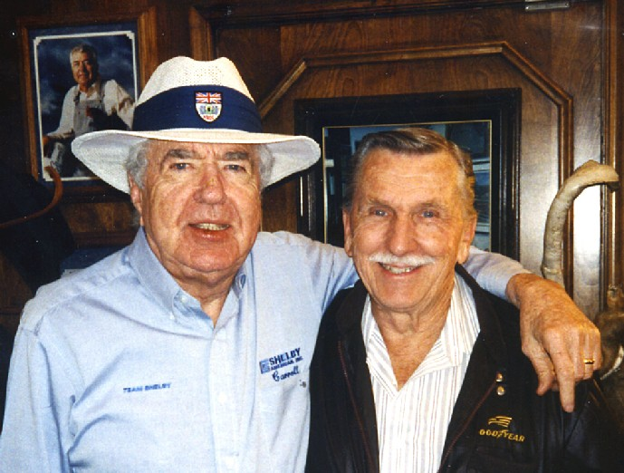
Shelby and Guldstrand were great friends.

JIM PARKINSON
By Art Evans

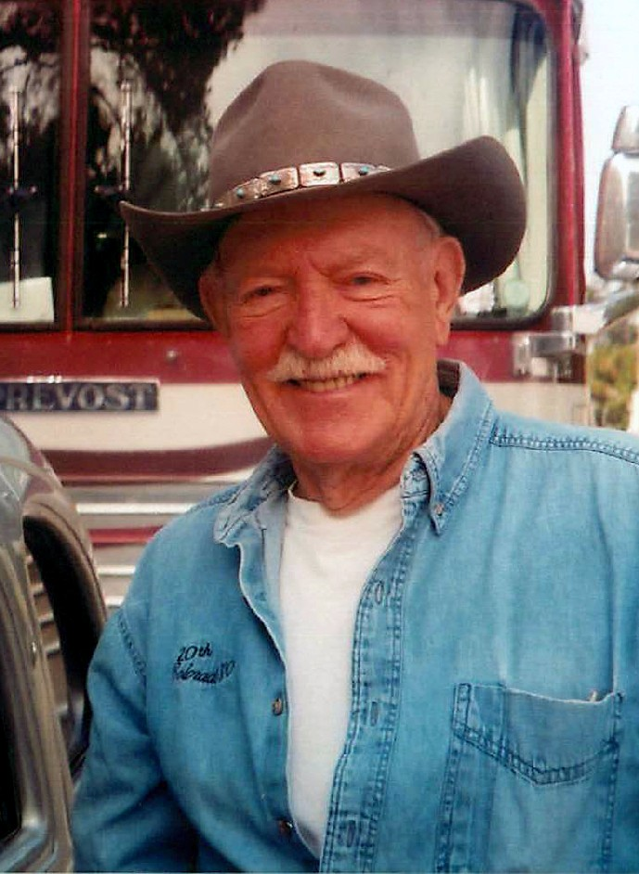

It is my sad task to tell you that Jim Par- kinson left us on Saturday, August 22. He was 83 years old. Parky, as we called him. He and I were good friends since the fifties.
When he, as a dealer, sold me three used cars at different times. He raced extensively and I took a number of pictures of him at the wheel. He was a long-time and active non- member of the Fabulous Fifties.
In the early fifties, Parkinson was one of those who turned their hobby into a business and became car dealers. He was a very ta- lented race driver and had the ability to be a top-ranked professional had he chosen to pursue that course.
James Harlin Parkinson was born on April 22, 1932 in Rugby, North Dakota. His father traced his ancestors to early settlers from England while his mother emigrated from Norway when she was a child. Parky grew up in North Dakota where his father had a farm.
Jim said he learned to drive in a 1936 Chevrolet Coupe. “I was seven years old and my dad showed me how to steer it through the fields around our farm. I had to stand up in order to see over the steering wheel! When I was eight years old I operated our small tractor.” When Parky was nine, he got his first job driving a truck hauling grain.
Parkinson went to the Willow City High School where he played basketball and was on the track team. But after his first year he spent another year at Brown Military Acade- my near San Diego. He moved to California in 1949 and got a job driving trucks, which he did for almost four years. At the same time, he had a part-time job in a foreign-car repair shop in Burbank. In 1952, he bought his first sports car, an MGTD.
Jim saved his money and, along with his cousin Duane Fuerhelm, bought out the re- pair shop where he worked in 1953. They paid $3,000 and renamed it the Burbank Sports Car Center. (I remember it well. Parky sold me an MGTD with a V8-60 engine. What fun I had when a stock MG tried to drag me at stop signs!) Soon both partners started to race. Jim’s first was at Willow Springs on May 9, 1954 in his TD.
In 1954, they acquired a new-car fran- chise for the MG-Austin-Morris line and in 1955, they added an Austin-Healey dealer- ship and raced that marque too. Jim was very successful in Austin Healeys including class wins at Sebring where he ended up running a total of seven times.
Jim bought out Duane’s interest in 1956, and then opened an additional location he called Italiano Motors selling a number of Italian brands and also added a used-car lot. Parkinson continued to expand with Jaguar, Renault, Peugeot and Lotus.
Parkinson’s racing history extended from 1954 through 1964. He entered a total of 129 events and finished 99 of them. He scored 11 overall victories and 22 class wins.
The 1956 6-Hour Race at Torrey Pines was among a number of his other class wins in his MGA. At times, he would race two different cars in different races at the same event.

For instance, at Paramount Ranch on Satur- day, December 7, 1957, he won Race 6 in a Ferry Renault and was third overall in the production-car race in his MGA. The next day he was 2nd driving his MGA in Race 8.

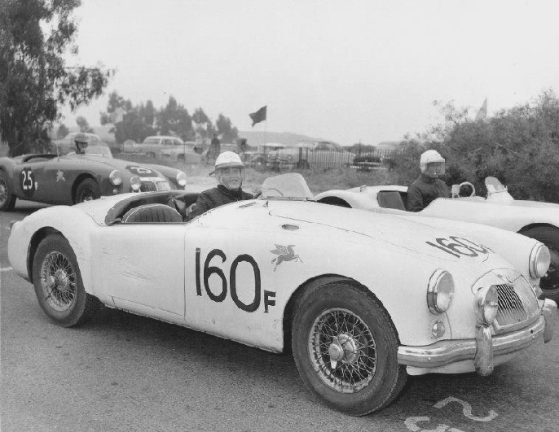
Jim Parkinson in his MGA at Paramount.

Parkinson remembered Paramount Ranch for me in my book, Paramount Ranch Re- membered: “The Paramount Ranch race track was one of my favorites in my racing days. Although my memory is foggy about indi- vidual races, Art tells me I drove more times there than anyone else. The record shows there were three cars I drove there—the Ferry Renault in Class H, the MGA in production under 1500cc and the Austin Healey 100S. (below) We were obviously very busy, trying to keep them all going for a weekend event.”

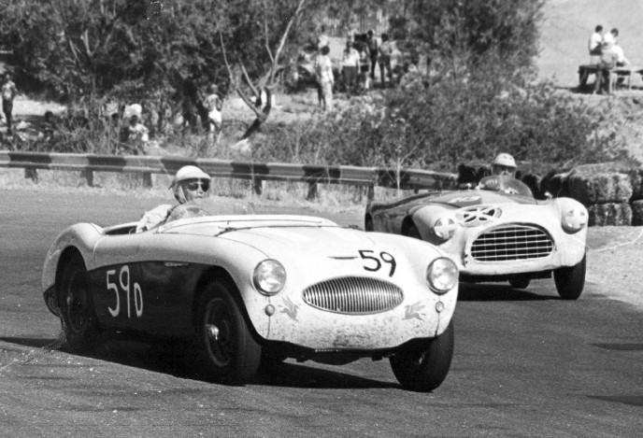
In 1958, Jim was joined by his cousin, Dan Parkinson, to become the importer and distributor for Abarth until Abarth retired and sold his company to Fiat. During that time, both cousins raced Abarths, each chalking up a number of class wins.
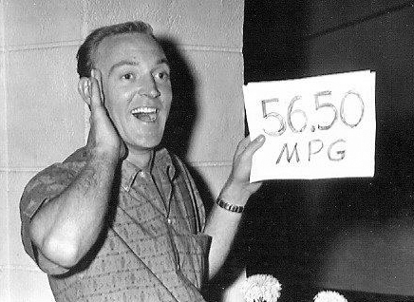In 1959, there were two Mobilgas Econ- omy Runs, one for domestic cars, the other for imports. Jim won the import event in an Austin-Healey Sprite, averaging 56.50 miles per gallon. Then won the domestic one in a Cadillac with 19.56 mpg.
In 1969, Jim sold his Burbank operation and moved to Orange County where he opened a VW dealership which he sold two years later to start his Newport Datsun and Beach Imports business in Newport Beach. Later, he added Tustin Nissan and Tustin Buick-Pontiac-GMC. His sons, Joe and Mark, worked with him at the dealerships and eventually took over when Jim retired.
Today, the Parkinson operation—headed up by Mark Parkinson—includes not only Tustin Buick GMC, but also Tustin Classic Cars, a Hummer franchise and the factory distributorship for Nu Art Can Am cars. In addition, Mark is the custodian of the Tustin Auto Classic Car Collection. Mark remarked that “Growing up in a racing family was a great experience. I still have my comme- morative button from the First Monterey Historics. I think 35 cars showed up to race and we were impressed.”
In 1963, Jim Parkinson changed gears and piloted a big-bore car, the Campbell Spe- cial, driving it for its creator, Bill Campbell. Campbell had extensive experience in dry- lake racing and had his own boat company. His special was powered by a highly- modified 283 CID Chevy engine and weighed only 1,400 pounds. Initially it was driven by Bob Harris who won at Riverside on June 24, 1962.
Campbell entered Parkinson in seven SCCA races during 1963. He was first overall at Del Mar on April 28 and again at Santa Barbara on May 12. The following year, Parky’s last before he hung up his helmet, he drove a Cooper Monaco three times and an MGB at Sebring failing to finish, however, due to mechanical problems.
During his later years, Parky had so many hobbies he hardly had time for business. In addition to sports-car racing, he rode motor- cycles, both dirt and touring, flew his own airplane, skied, had a street rod and toured in his motor home. Jim had a 31-foot Catalina sloop that he raced two times in the Newport to Ensenada. Sailing was another pastime we had in common as I had and raced a 30-foot Newport. He will be fondly remembered by his many friends.
Jim is survived by his close and long- time girlfriend, Sharon “The Teach” St. Clair, his two sons, Joe and Mark, three grand- daughters, five great grandchildren and his sister, Gloria Dickey.

PARKINSON LETTERS
I met Jim Parkinson in 1962 when my "boyfriend," John Dixon, put me in touch with him to buy my first car. I decided on a black Renault Dauphine and while on a test drive Jim tried to discourage the purchase. He reached over from the passenger seat and jiggled the turn signal and said, " why would you want to buy a Mickey Mouse car like this with all this plastic?" My response was that it was cute and really all I could afford -
$500. As it turned out the car was a magnate
of sorts. It managed to attract two accidents, due to other folks' mistakes, that paid off in more cash than I paid for it. Then I was driv- ing merrily down Wilshire Blvd. in West- wood and, in front of Pick's Restaurant, it caught on fire. After the fire department made a mess by hacking and spraying, my hero, John Dixon, cleaned it up and got it running again. No wonder I decided he was the guy for me. I managed to sell the black beauty and Jim sold me another cute Renault
- a Caravelle convertible. Over the many years, I loved to remind Jim of my "Mickey Mouse" car and especially enjoyed spending time with him and Sharon. It was great fun listening to the many 1950s racing stories of John and Parky - often with two different ways of remembering as they were in compe- tition in their MGs. —Ginny Dixon

We are so sorry to hear about Jim's pass- ing. He was a great guy and a great driver. As you know my Dad and he were often on track together. I have a great picture of him in my garage. Jim in his Austin Healy at the start of a race at Paramount Ranch next to Dan Gur- ney in his Porsche Speedster and Dad in the AC Bristol. I love that picture. Several years ago I ran into Jim at one of the Fab 50's events at Willow Springs. After talking to Jim for a few minutes he finally realized who he was talking to; he thought I was my Dad!
—Bill Oker

Here are my recollections of my intro- duction to Jim’s driving prowess: We were in the pits at Pomona, 1960 or ‘61. It was raining heavily, I recall watching more than one Porsche hydroplane into a spin in stand- ing water on the main straight. We were watching Jim’s crew hastily finishing setting up the Campbell Special as the starting flag fell. He passed by on the next lap, artfully feathering the power as the car lost and re- gained traction, making up time big time. It was a masterful piece of driving in what looked to be a beast of a car, walking a very thin line between maintaining control and exiting the course wrong end first.
—Dave Norton

Jim Parkinson was a real car guy; met him in 1962 when he had a M.G./ Healey dealership in Burbank; (I worked for the other guy: Peter Satori of Pasadena") used to dealer-trade M.G.'s; Healeys; whatever we needed; or what he needed; we stayed in touch; I worked with his brother-in-law "Duane Fuerhelm" (Think his in-law?) back when he ran the Datsun team. Duane kept my Datsun powered Lotus X running as the best one of those could run;(Gratis); "Parky" his sons Joe and Mark and I did stuff together thru the "Tustin Auto Mall" I would run into "Parky" at Monterey every year; wondered why not this year; now I know. Jim grew up near me in North Dakota; maybe 80 miles away. We always had a kinship; another good (great) one gone! —Jerry Quam

